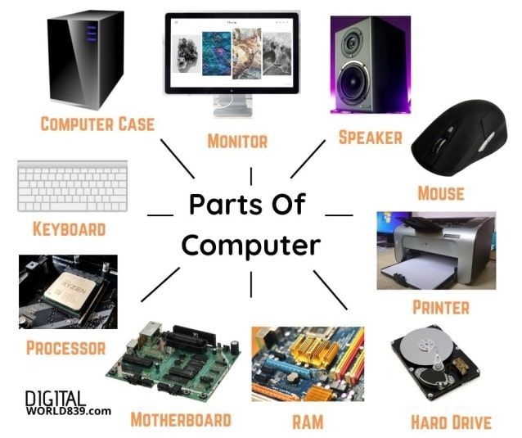
HARDWARE PARTS OF
COMPUTERS

